CMPS 350- Web Development Fundamentals

**Midterm Exam**

|  |  |
| --- | --- |
| **Student Name** | Syed Ahmad Faraz Subzwari |
| **Student Id** | SS2105006 |
| **Email** | SS2105006@qu.edu.qa |

**Grading Rubric - - In the *Functionality* column please specify either: *Working (completed x%)*, *Not Working (completed x%)* or *Not done*.**

|  |  |  |  |  |
| --- | --- | --- | --- | --- |
| Rubrics | % | Functionality | Quality of the Implementation | Score |
| 1. Displayed the movie cards with the style and responsiveness | 35 | ***Working (completed 100%)*** | Excellent | 35 |
| - Successfully fetches and displays movie data in a responsive card layout from the API |  | ***Working (completed 100%)*** | Excellent |  |
| - All specified movie details are accurately displayed |  | ***Working (completed 100%)*** | Excellent |  |
| - Implements grid with RAM technique for responsiveness |  | ***Working (completed 100%)*** | Excellent |  |
| 2. Cache the data into LocalStorage | 20 | ***Working (completed 100%)*** | Excellent | 20 |
| - Efficient caching of movie data in localStorage to reduce API calls |  | ***Working (completed 100%)*** | Excellent |  |
| - Correct utilization of cached data before fetching new data |  | ***Working (completed 100%)*** | Excellent |  |
| 3. Display the Movie Details from database | 25 | ***Working (completed 100%)*** | Excellent | 25 |
| - Displays detailed information and trailer when "Show More" is clicked |  | ***Working (completed 100%)*** | Excellent |  |
| - Added the movie trailer |  | ***Working (completed 100%)*** | Excellent |  |
| - Functional "Back" button to return to the list |  | ***Working (completed 100%)*** | Excellent |  |
| 4. Delete movie from the database | 20 | ***Working (completed 100%)*** | Excellent | 20 |
| - Correctly removes movie from UI list and localStorage |  | ***Working (completed 100%)*** | Excellent |  |
| - Dynamic updates to UI after deletion |  | ***Working (completed 100%)*** | Excellent |  |
| Provide screenshots in testing.docx | - | ***Working (completed 100%)*** | Excellent |  |
| - Documentation of testing process with screenshots |  | ***Working (completed 100%)*** | Excellent |  |
| Note: -10pts if missing |  | N/A |  |  |
| TOTAL GRADE | **100 PERCENT** | | | |

**Possible grading for functionality**:

* ***Complete and Working*** (get 70% of the assigned grade),
* ***Complete and Not working*** (lose 40% of assigned grade)
* ***Not done*** get 0.
* The remaining grade is assigned to the quality of the implementation.
* Must submit screenshots in this **Testing-GradingSheet.docx** (otherwise - 10pts).

## Testing evidence

Add the screenshots of your work for the all the parts

**GET MOVIES DATA AND DISPLAY AS CARD:**





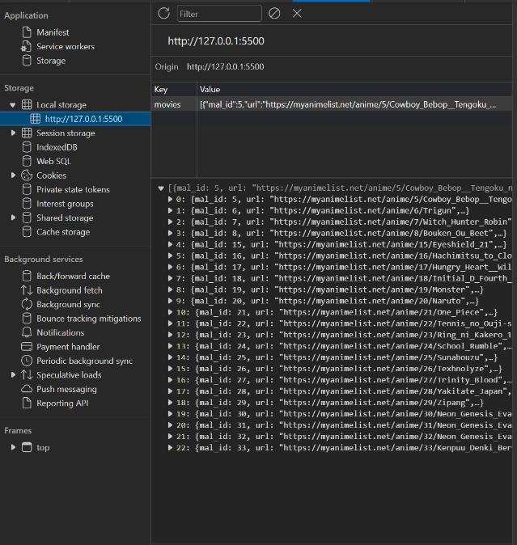As we can see, the page is fetched and is displayed with cards with the Ram Technique.

Also, on the image on the right, the data of the movies are saved.

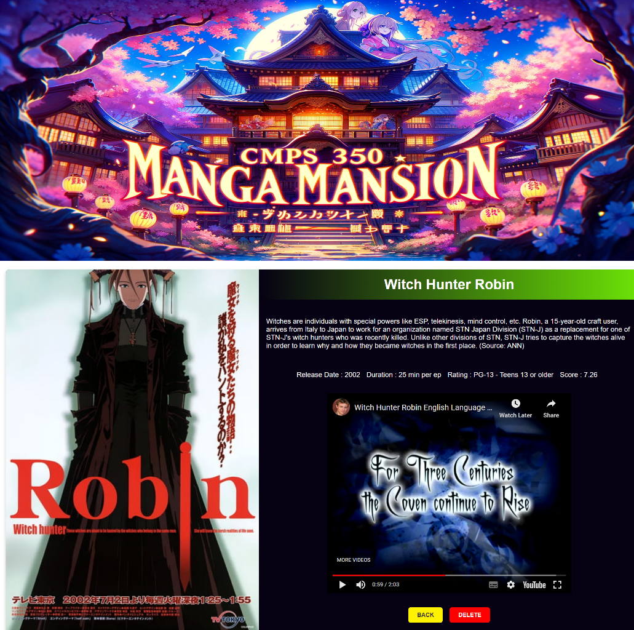This is the result of clicking the show more button.

And whether I click delete here or delete in the previous UI, the result is the same which is that it will be deleted.

Please observe the next screen shot where I have now deleted the Witch Hunter Robin Movie.

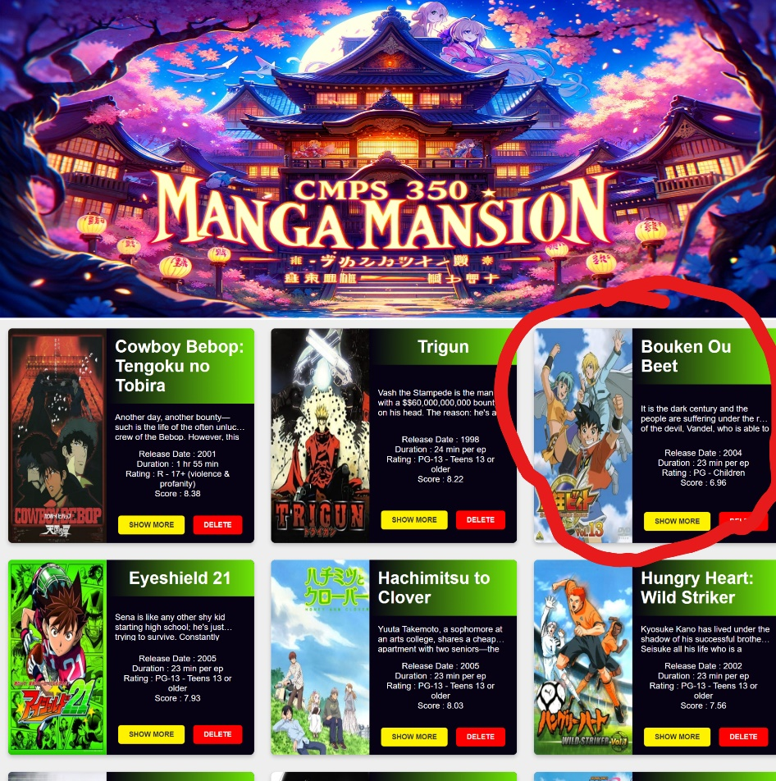

As we can see the movie has been deleted and other movies have dynamically moved here to fill the space.